Lab: Linux and Linux Shell
Lab for the "Containers and Clouds" course @ SoftUni

Configure Connectivity of the VM
The first step is to open the link – https://labs.play-with-docker.com/. 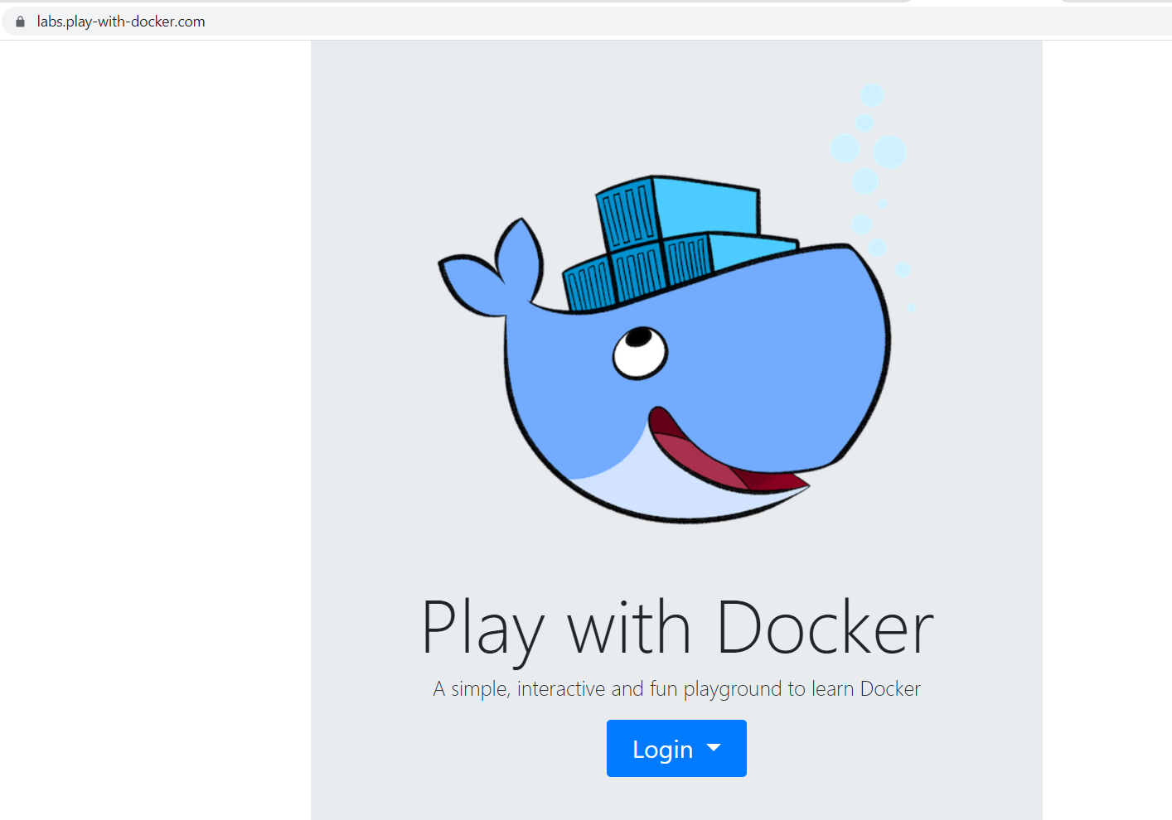
Then press the [Login] button and click on "docker". A new dialog box opens, which is for docker registration. If you don't have a registration click on [Sign Up]. You have to create an account with a username, password and email. Then sign in to your account. It takes you to a page to select the plan you want – click on "Continue to Free" (Personal plan). Log in to the email you registered with and confirm your account. You may need to reload the page until you see this:
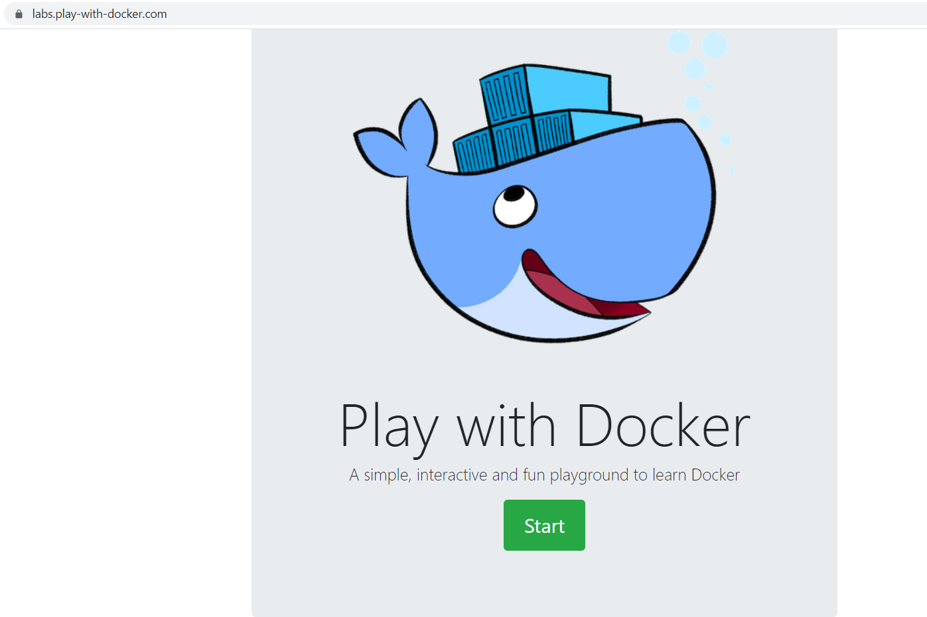
Click on the [Start] button.
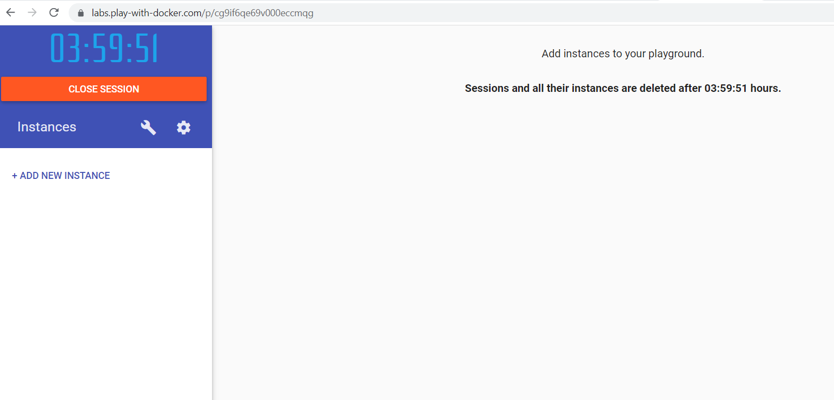
You should see this. Click on [+ add new instance].
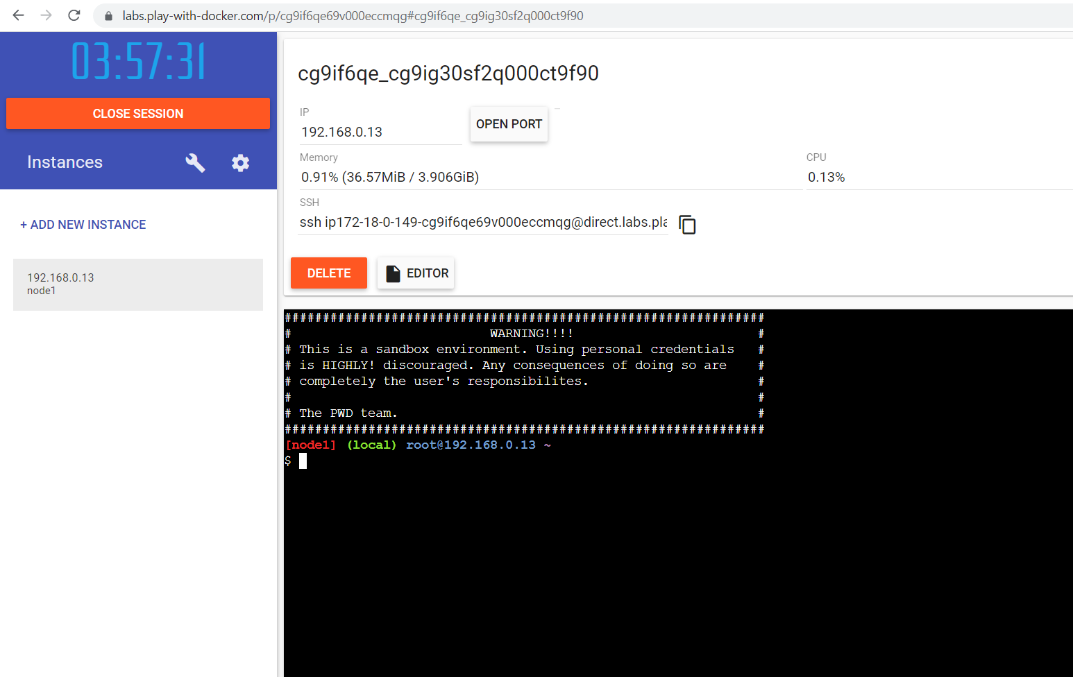
We are ready for work!

Getting to Know Environment Variables
Let's start with the environment exploration process. Try out the set command and look at its result:
↓
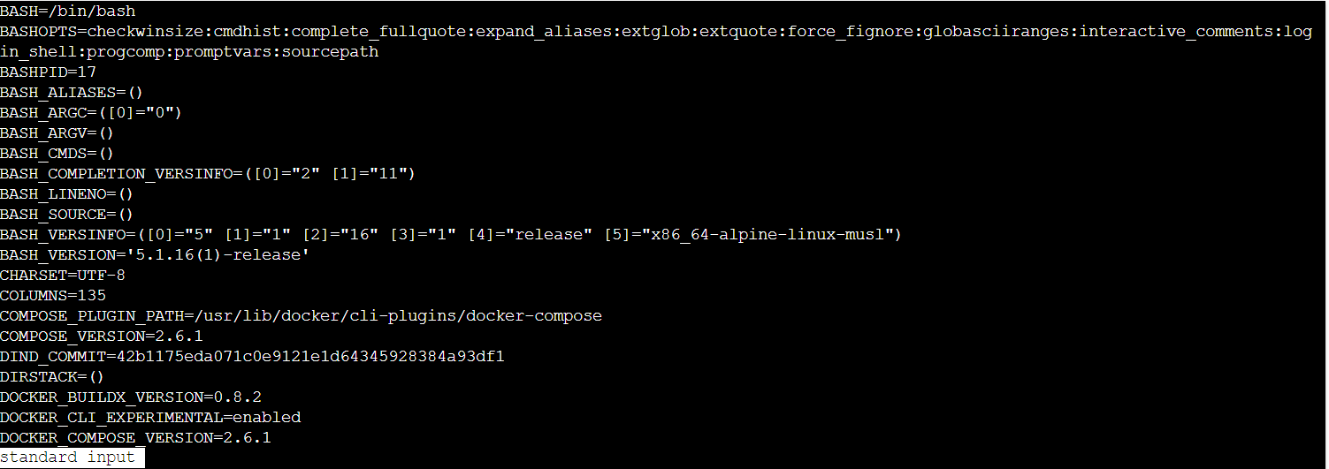
When executed without parameters, set returns information about the environment – variables and functions. Again, the information will differ from distribution to distribution and between versions of distribution.
We added | less to the set command to display the command output, one page at a time. It is optional, but it's a good idea to use it when the output is longer. You can go to the next pages with [Enter] or quit with [q].
The set command can be used to modify the parameters that are driving the environment. In order to see what parameters are there, we can execute:
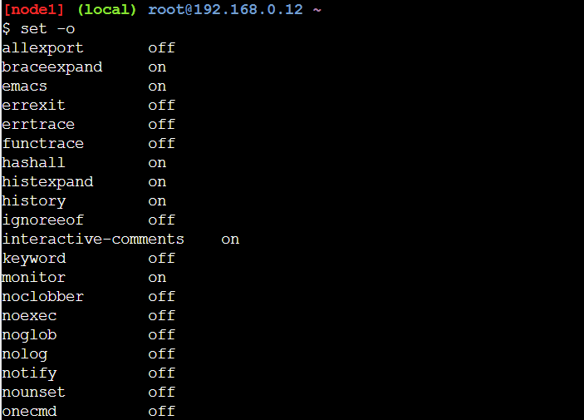
We can see the same information but prepared for re-use with:
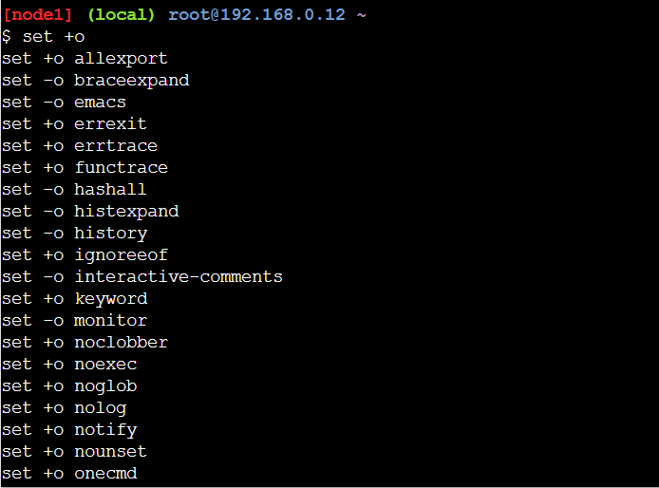
Let's change the flag that controls the amount of information shown during commands execution:
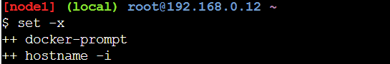
You should note that the minus ("-") is used to turn on a flag, while the plus ("+") is used to deactivate a flag. Now, we can execute few more commands:
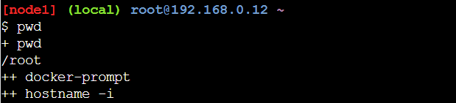
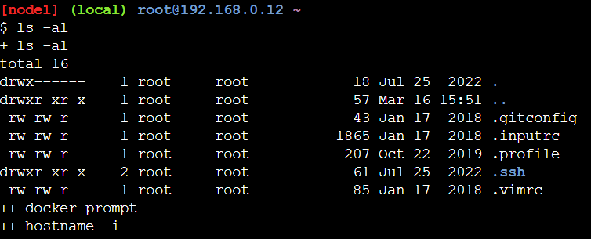
We can see that immediately after each command there is information aboutse what is going to be executed. This way we can see that instead ls, in fact something else is being executed – its alias or the statement it specifies.
It is time to deactivate the xtrace mode:
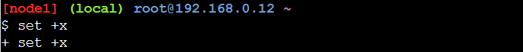
Now you will not be able to see what commands are executed.

Getting Help
Now it is time to explore ways of getting help about different commands.
For the shell built-in commands, we can use the help command. If we execute it without parameters, it will return all built-in commands:
↓
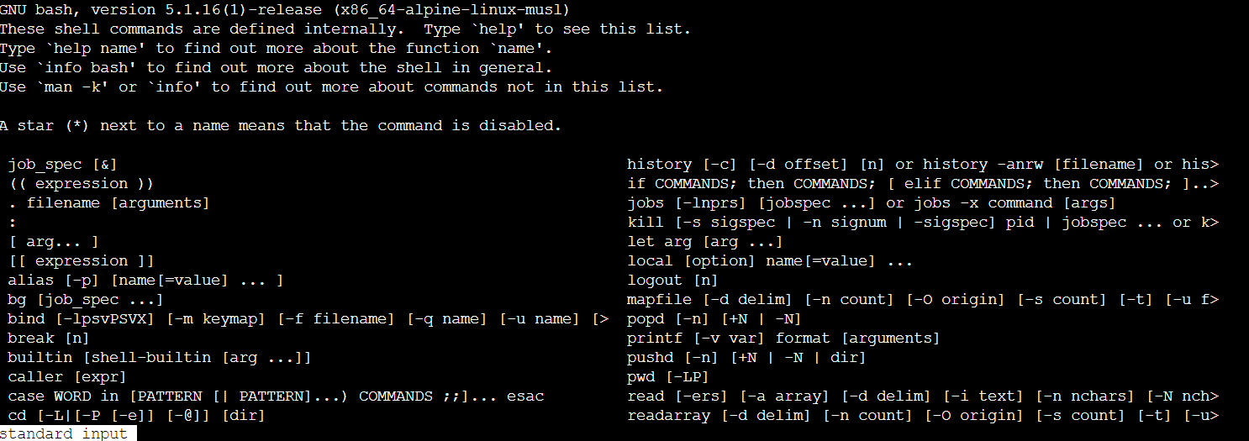
In order to ask for a command, we must execute it like:
↓
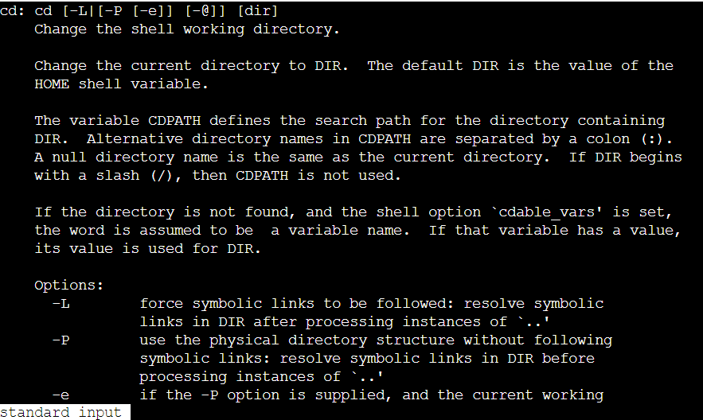
Most external commands offer integrated help. The ways to ask for this information vary, but typically we can use:
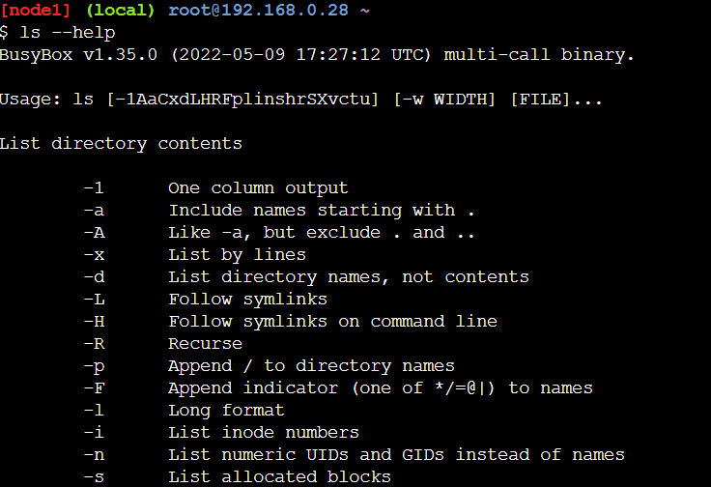
When using man, it is good to know the following set of keys:
- Key [h] shows help information
- Key [q] either exits the help mode or the man
- If we want to search for something from the current cursor position onwards, then we can press [/], then enter the string and then press the [Enter] key. Once in this mode, we can press [n] key to move forward over the matches, or the [N] key to move backward
- Searching backwards works the same, but it is initiated with the [?] key
A quick search in man can be done on the command line with:
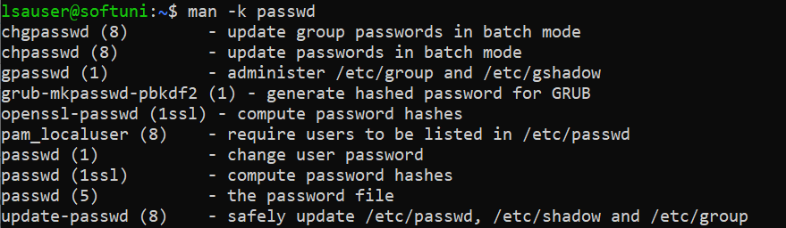
Similar effect can be achieved by using the apropos command:
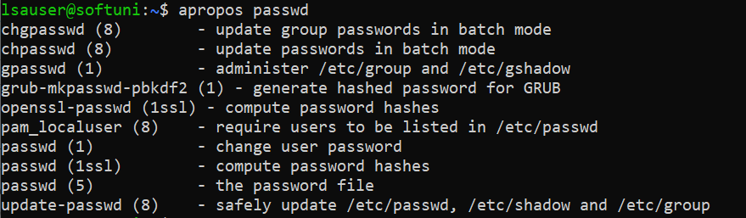
Beside man, usually there is an alternative and modern help system available – info. We can use it the same way:
↓
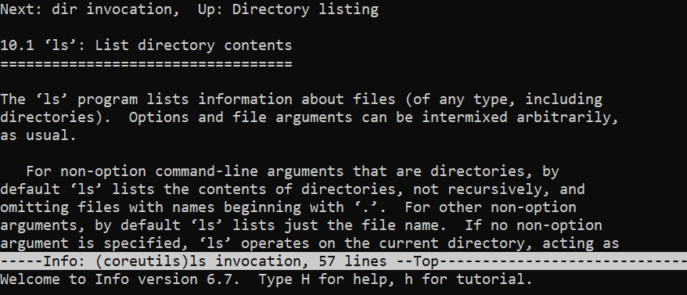
For help inside the tool, we can press the [h] key. The help screen can be closed with the [x] key. No matter where we are in the tool, we can exit with the [q] key.

